EXPERIMENT 9

9.1.1//Count Vowels in a String-1
Ans:ALGORITHM:
Step 1: Start
Step 2: Read string a
Step 3: Set count = 0
Step 4: For each character i in string a
Step 5: Check if i is a vowel (A, E, I, O, U, a, e, i, o, u)
Step 6: If yes, then count = count + 1
Step 7: Repeat loop until end of string
Step 8: Print count
Step 9: Stop
FLOWCHART:
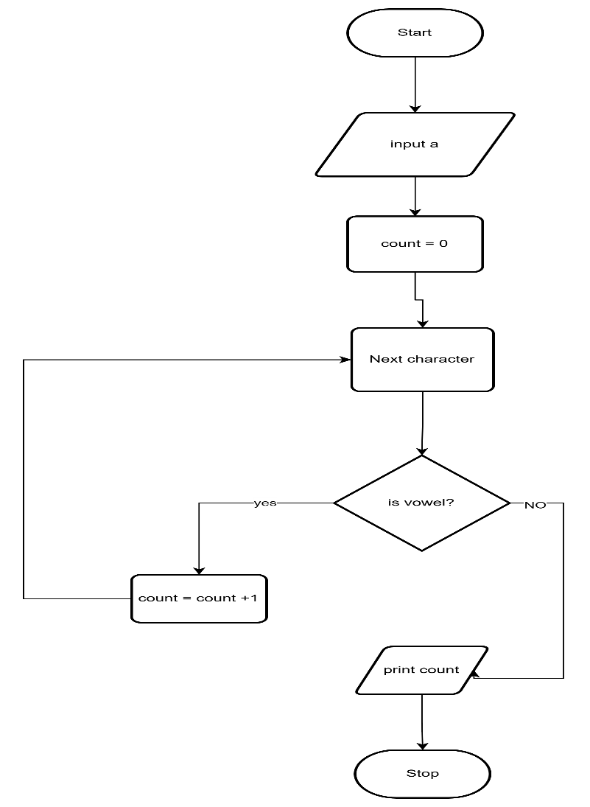

CODETANTRA:
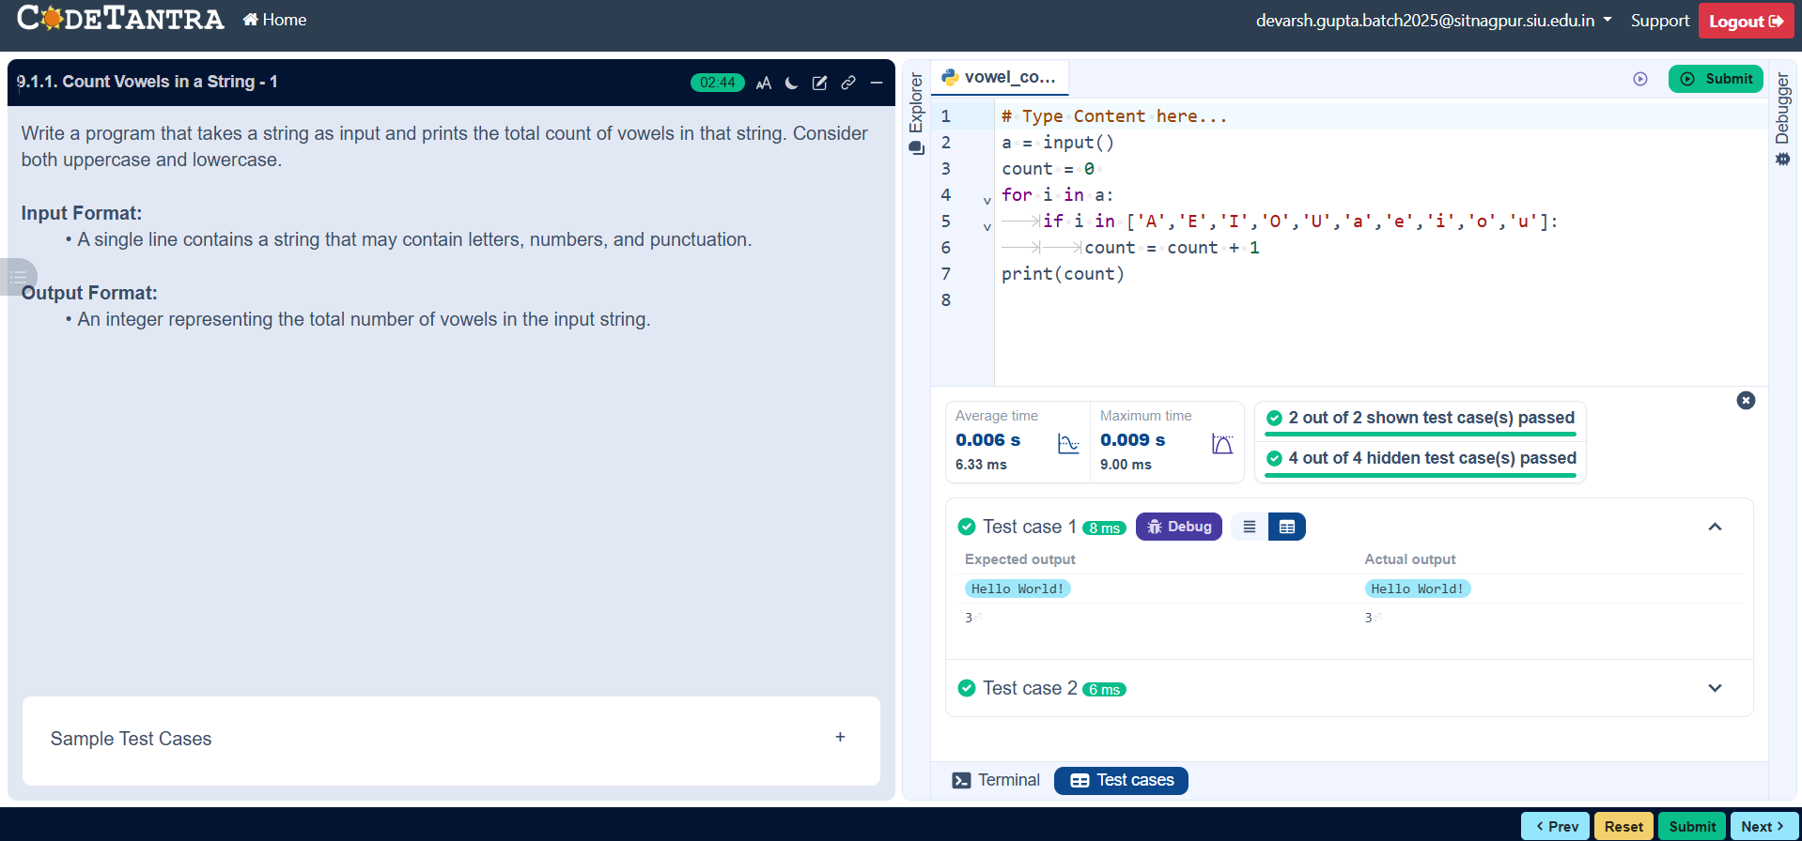

9.1.2//Palindrome or not
Ans: ALGORITHM:
Step 1: Start
Step 2: Read string s
Step 3: Find length of string l
Step 4: Set flag = True
Step 5: Set i = 0
Step 6: If s[i] ≠ s[l-1-i] then set flag = False
Step 7: Set i = i + 1 and repeat Step 6 until i < l
Step 8: If flag = True then print "Palindrome"
Step 9: Else print "Not a Palindrome"
Step 10: Stop
FLOWCHART:
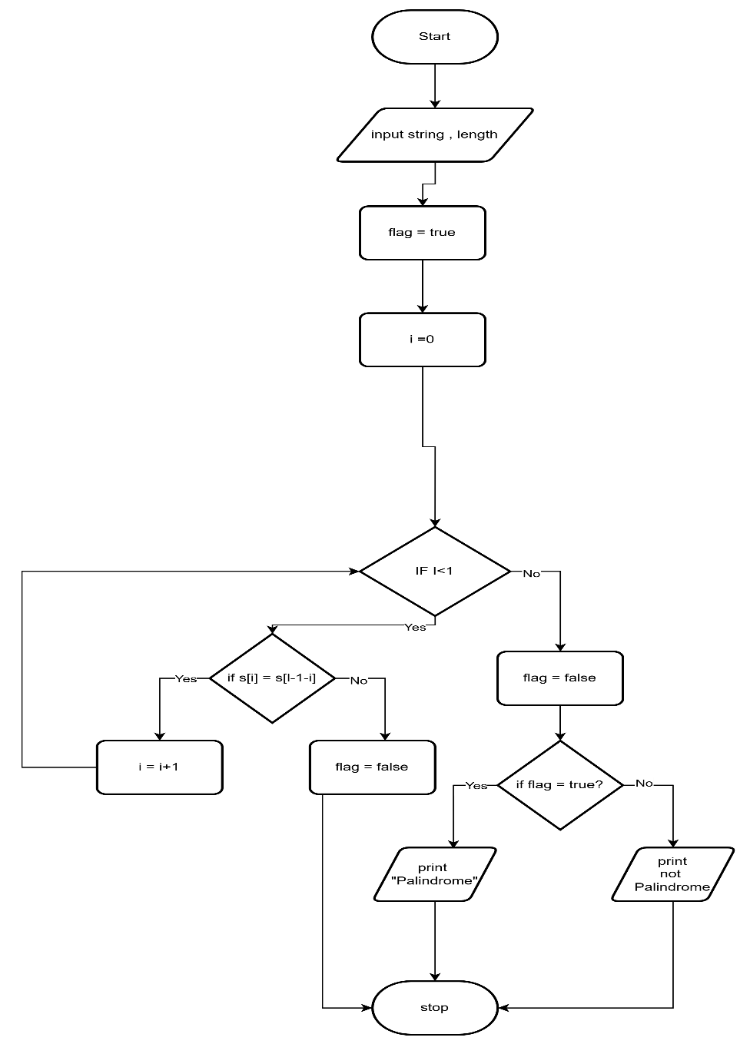

CODETANTRA:
